Assignment 1(a) :

Create a responsive web page which shows the ecommerce/college/exam admin dashboard with sidebar and statistics in cards using HTML, CSS and BootstrapHTML stands for Hyper text markup language.

Html is a standard language for creating webpages.

It describes the structure of webpage

Structure of html document:

<!DOCTYPE html>

<html>---------------------------🡪 root element of page

<head>-----------------------------🡪 info of page

<title>Page Title</title>

</head>

<body>

<h1>My First Heading</h1>-----------------------🡪 large heading

<p>My first paragraph.</p>

</body>

</html>

All HTML documents must start with a <!DOCTYPE> declaration. The declaration is not an HTML tag. It is an "information" to the browser about what document type to expect.It tells the version of html (html5)

Basic structure of html :

Tags :describe that the browser should do something instead of simply displaying - paired: text is placed between a tag and its companion tag , unpaired tags: does not have companion tag

Elements : element content is everything between the start and end tag

Attributes: these are added to a tag to provide the browser with more information about how the tag should appear or behave.

Document structure :

Head – basic information like title, information style, javascript declaration.

Body – content displaying in the browser window

**CSS:**

Cascading Style Sheets

control the layout of multiple web pages all at once.

define styles for your web pages, including the design, layout and variations in display

**Bootstrap:**

Bootstrap is a free and open-source tool collection for creating responsive websites and web applications.

HTML, CSS, and JavaScript framework for developing responsive, mobile-first websites.

websites are perfect for all the browsers, for all sizes of screens etc by using bootstrap.

Why Bootstrap?

• Faster and Easier Web Development.

• It creates Platform-independent web pages.

• It creates Responsive Web-pages.

• It is designed to be responsive to mobile devices too.

• It is Free! Available on [www.getbootstrap.com](http://www.getbootstrap.com)

**Assignment 1(b):**

Write a JavaScript Program to get the user registration data and push to array/local storage with AJAX POST method and data list in new page.

**AJAX:**

AJAX stands for Asynchronous JavaScript and XML. AJAX is a new technique for creating better, faster, and more interactive web applications with the help of XML, HTML, CSS, and Java Script. Ajax uses XHTML for content, CSS for presentation, along with Document Object Model and JavaScript for dynamic content display

AJAX is a web browser technology independent of web server software.

Example :

With AJAX, when you hit submit, JavaScript will make a request to the server, interpret the results, and update the current screen.

XML is commonly used as the format for receiving server data.

AJAX cannot work independently. It is used in combination with other technologies to create interactive webpages:

JavaScript:

[JavaScript](https://developer.mozilla.org/en-US/docs/Glossary/JavaScript) is a scripting language that enables you to create dynamically updating content, control multimedia, animate images

DOM**: Document object model**

Represents the structure of XML and HTML documents

**DOM** is an **API** (Programming Interface) for **JavaScript**

CSS:

Allows for a clear separation of the presentation style from the contentand may be changed programmatically by JavaScript.

XMLHttpRequest:

JavaScript object that performs asynchronous interaction with the server.

AJAX – Events: onreadystatechange Event Properties:

onReadyStateChange, readyState, status

XMLHttpRequest object properties:

readyState, onreadystatechange, responseText, responseXML, status, statusText

XMLHttpRequest object methods :

open('method', 'URL', asyn) , send(content) , setRequestHeader('x','y'), getAllResponseHeaders(), getResponseHeader(x), abort()

**Assignment 2(a):**

Create version control account on GitHub and using Git commands to create repository and push your code to GitHub.

Git:

**It is used for:**

**• Tracking code changes**

**• Tracking who made changes**

**• Coding collaboration**

What does Git do?

• Manage projects with Repositories

• Clone a project to work on a local copy

• Control and track changes with Staging and Committing

• Branch and Merge to allow for work on different parts and versions of a project

• Pull the latest version of the project to a local copy

• Push local updates to the main project

Why Git?

Developers can work together from anywhere in the world.

Developers can see the full history of the project.

Developers can revert to earlier vers . What is GitHub

• Git is not the same as GitHub.

• GitHub makes tools that use Git.

• GitHub is the largest host of source code in the world, and has been owned by Microsoft since 2018.ions of a project.

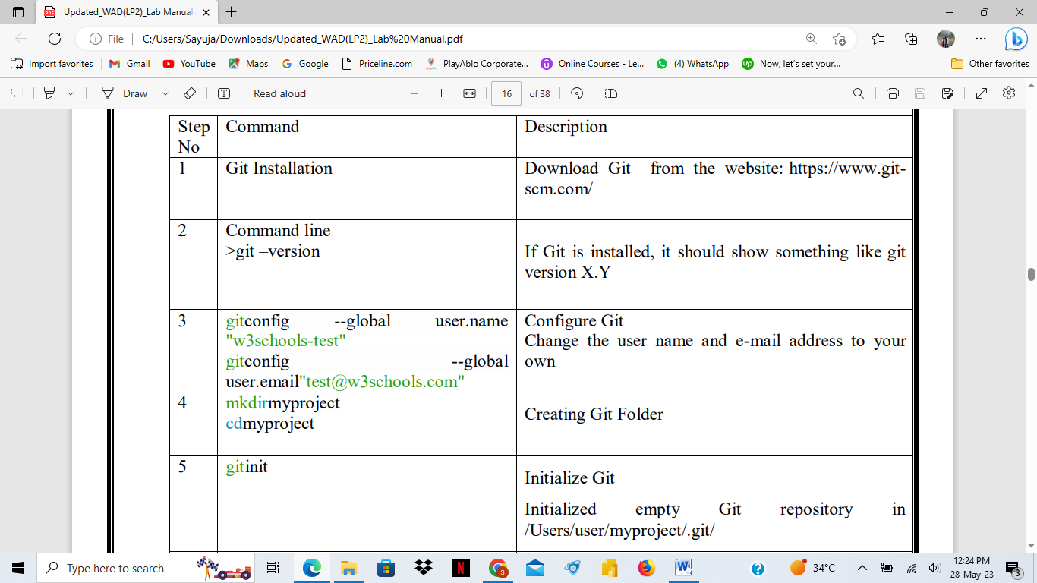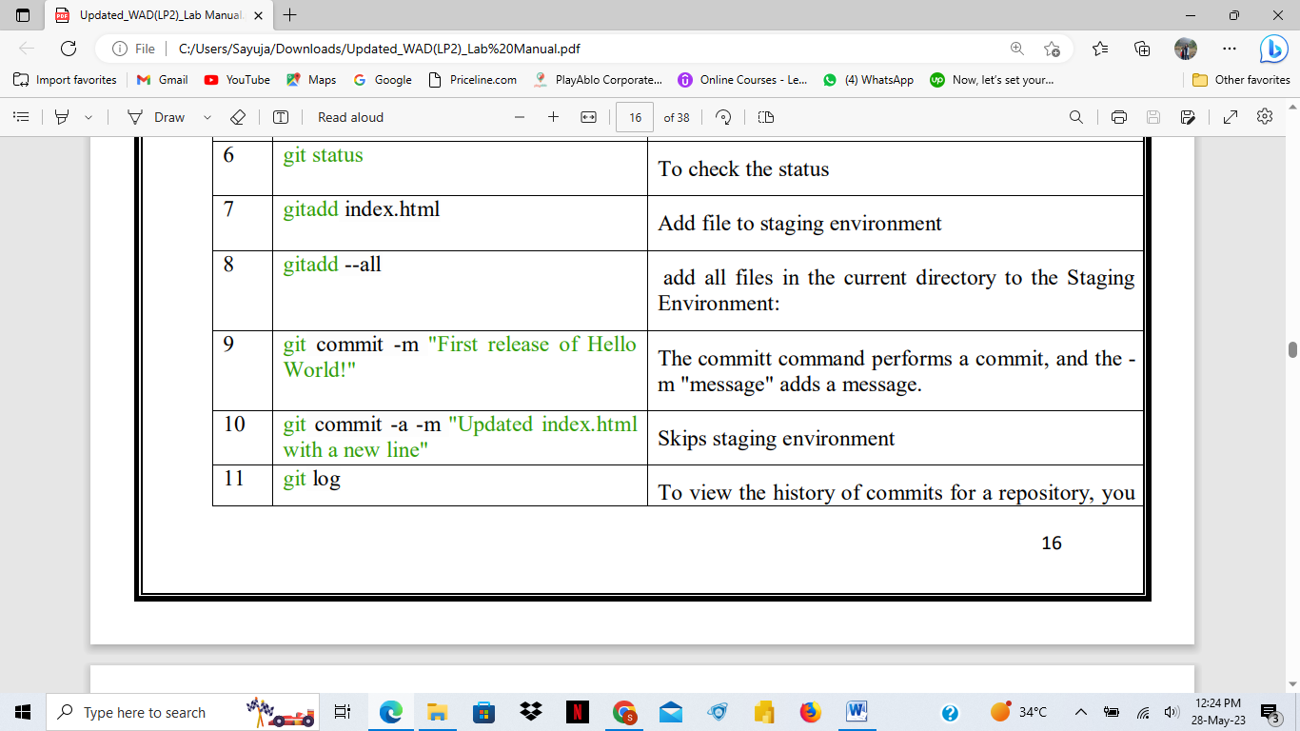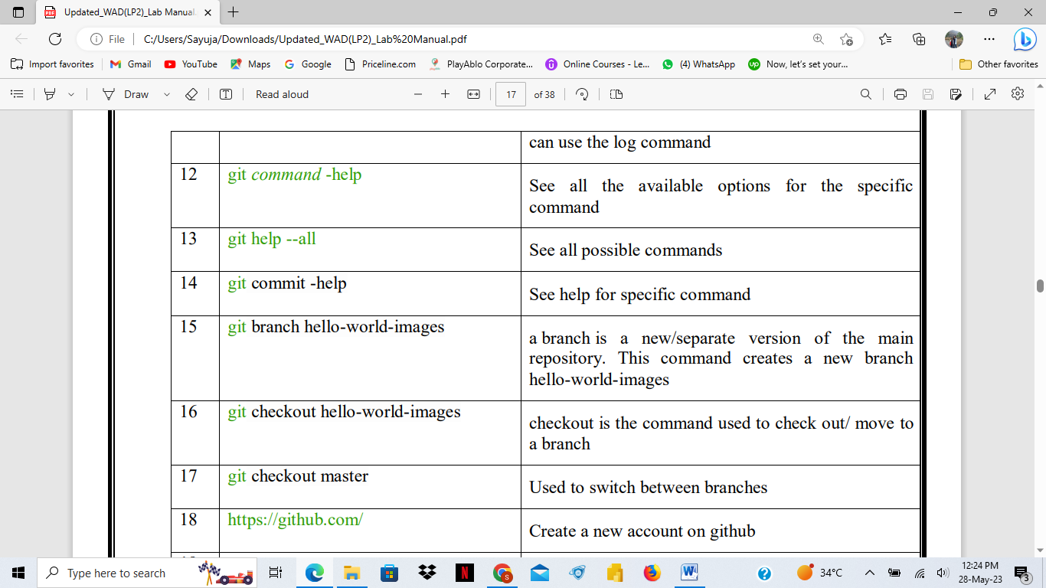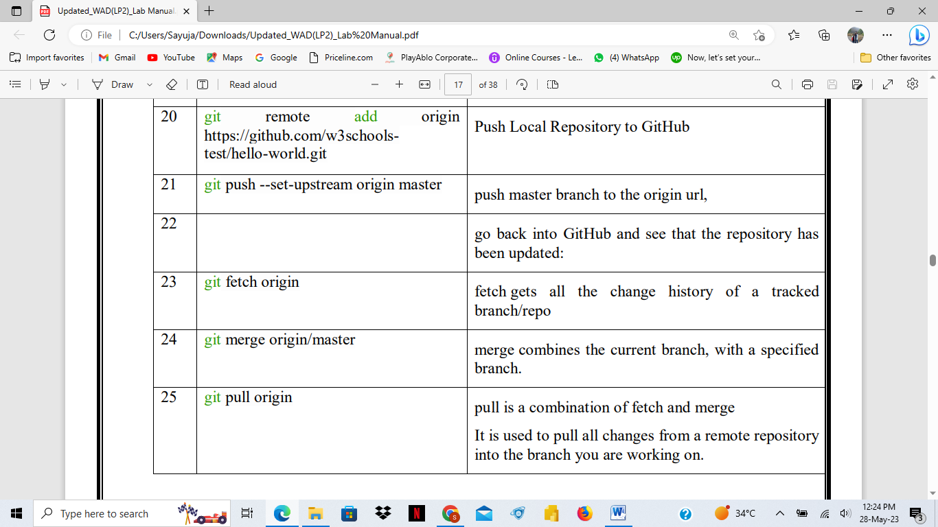

**Assignment 2(b):**

Create Docker Container Environment (NVIDEIA Docker or any other).

A container is a standard unit of software that packages up code and all its dependencies so the application runs quickly and reliably from one computing environment to another.

A Docker container image is a lightweight, standalone, executable package of software that includes everything needed to run an application: code, runtime, system tools, system libraries and settings.

 Docker Container is a standardized unit which can be created on the fly to deploy a particular application or environment. It could be an Ubuntu container, CentOs container, etc. to full-fill the requirement from an operating system point of view. Also, it could be an application oriented container like CakePHP container or a Tomcat-Ubuntu container etc.

**Requirements: -**

**1. Minimum Windows 10 (Home and All Other Editions)**

**2. Hyper-V (In-Built and can be Enabled)**

**3. Only 64bit Processor Architecture**

**4. Virtualization Enablement from Bios Level**

A Dockerfile is a simple text file with instructions and arguments. Docker can build images automatically by reading the instructions given in a Dockerfile

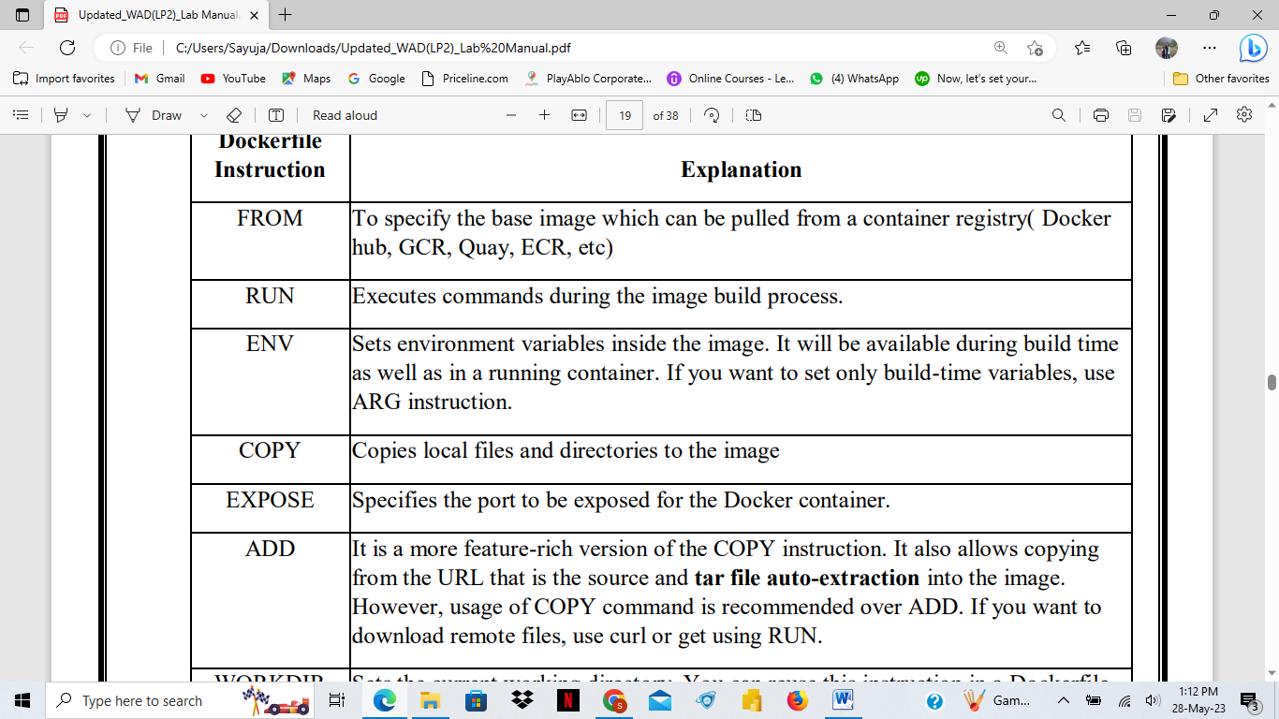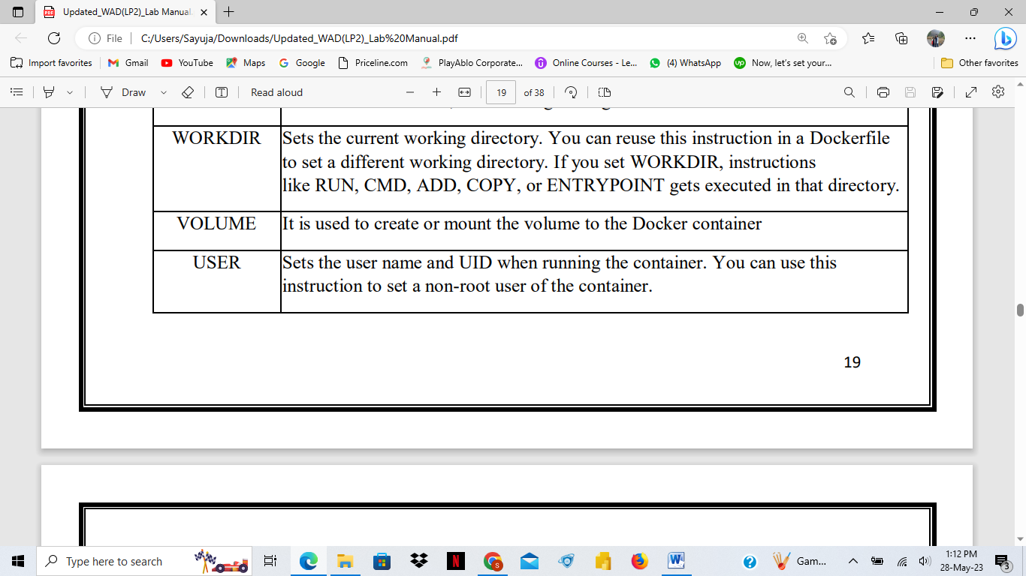

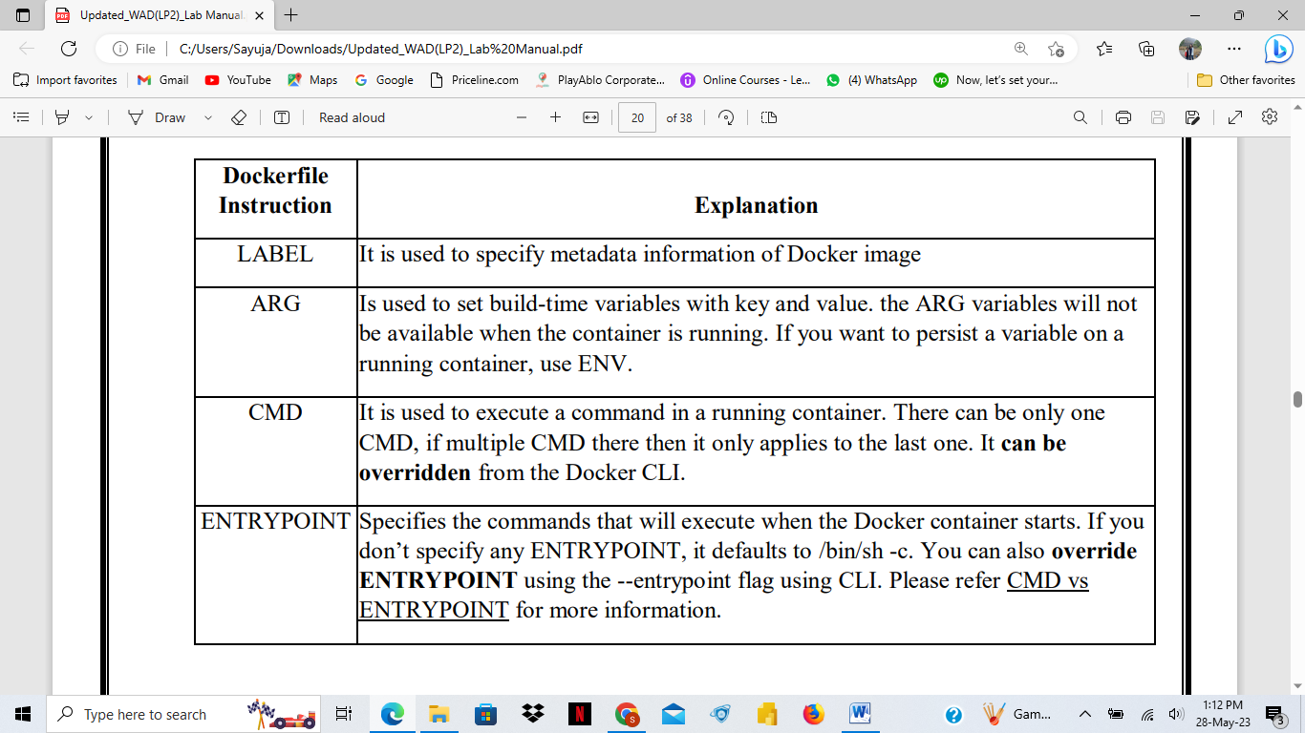

**Assignment 2(c):**

Create an Angular application which will do following actions: Register User, Login User, Show User Data on Profile Component.

Angular is a typescript based free and open source web application framework developed by Google. Angular 10+ is a JavaScript framework which is used to create single page application. The Angular applications are created with the help of HTML and Typescript.

**Features:**

**High speed web application**

**Dynamic development**

**Full stack development**

**node_modules: contains folders of packages which are installed**

**• src folder: this is the place where we need to put all our application source code**

**22**

**• app folder: When we want to create any component, service or module, we need to**

**create it within this app folder.**

**• assets folder: you can store static assets like images, icons etc.**

**• environment folder: used to set up different environments.**

**• favicon.ico: It is the icon file that displays on the browser**

**• index.html: Starting point of our application.**

**• main.ts file**

**• polyfills.ts: used for browser-related configuration**

**• angular. json file: It contains the configuration of your angular project**

**• test.ts and karma.config.js: used for testing purpose**

**• Package.json: mandatory for every npm project**

**Architecture of angular:**

**Component – classes with decorator**

**Angular Modules -** provides the bootstrap mechanism that launches the application.

Angular Data Binding - communication between components and its view.

Directives and Pipes - Directives is a technique in Angular that adds additional behavior to the elements in the Angular applications. Pipes are used to transform the data.

**Assignment 3(a):**

Create a Node.JS Application which serves a static website

Node.js is an open source server environment

Node.js uses JavaScript on the server

Node.js eliminates the waiting, and simply continues with the next request.

Node.js runs single-threaded, non-blocking, asynchronous programming, which is very memory efficient.

* Node.js can generate dynamic page content
* Node.js can create, open, read, write, delete, and close files on the server
* Node.js can collect form data
* Node.js can add, delete, modify data in your database

Express.ji:

Express.js is a small framework that works on top of Node.js web server functionality to simplify its APIs and add helpful new features.

**Why Express ?**

* Develops Node.js web applications quickly and easily.
* Allows you to define application routes using HTTP methods and URLs**.**

**Assignment 3(b):**

Create four API using Node.JS, ExpressJS and MongoDB for CURD Operations on assignment 2.C

API (Application Programming Interface) are a set of functions and procedures that allow for the creation of applications that access data and features of other applications.

REST (Representational State Transfer) is a set of rules that developers follow while creating API.

MongoDB is an open-source database management system (DBMS) that uses a documentoriented database model. MongoDB is a NoSQL Database. MongoDB stores data in JSONlike documents, which makes the database very flexible and scalable

CRUD operations

Create- db.collection.insertOne()

, read- db.collection.find()

, update- db.collection.updateMany() • db.collection.replaceOne()

, and delete documents.- db.collection.deleteOne()

Assignment 4(a):

Create a simple Mobile Website using jQuery Mobile.

JQuery Mobile is a user interface framework, built on jQuery Core and used for developing responsive websites or applications that are accessible on mobile, tablet, and desktop devices.

Why Use jQuery Mobile?

It creates web applications that it will work the same way on the mobile, tablet, and desktop devices.

It is built on jQuery Core and "write less, do more" UI framework It is written in JavaScript and uses features of both jQuery and jQuery UI for building mobile-friendly sites

Assignment 4(b):

Deploy/Host Your web application on AWS VPC or AWS Elastic Beanstalk.

Cloud Computing:

referred to storing and accessing data over the internet. In cloud computing, you can access data from a remote server

AWS is Amazon Web Services offered by Amazon. It is a platform that offers flexible, reliable, scalable, easy-to-use and, cost-effective cloud computing solutions

The platform is developed with a combination of infrastructure as a service (IaaS), platform as a service (PaaS) and packaged software as a service (SaaS) offerings

It is a secure cloud services platform, offering compute power, database storage, content delivery and other functionality to help businesses scale and grow. In simple words AWS allows you to do the following things- Running web and application servers in the cloud to host dynamic websites.

Applications of AWS services

Amazon Web services are widely used for various computing purposes like:

• Web site hosting

• Application hosting/SaaS hosting

• Media Sharing (Image/ Video)

• Mobile and Social Applications

• Content delivery and Media Distribution

33

• Storage, backup, and disaster recovery

• Development and test environments

• Academic Computing

• Search Engines

• Social Networking

Extra:

What is W3C?

Js datatype- string, number, Boolean, null, undefined,object,date, array

What is JSON?

What is mvc?

What is reactjs?

Amazon EC2?